Task No 01: Perform the following task on the Excel sheet provided given below by using the built-in functions.

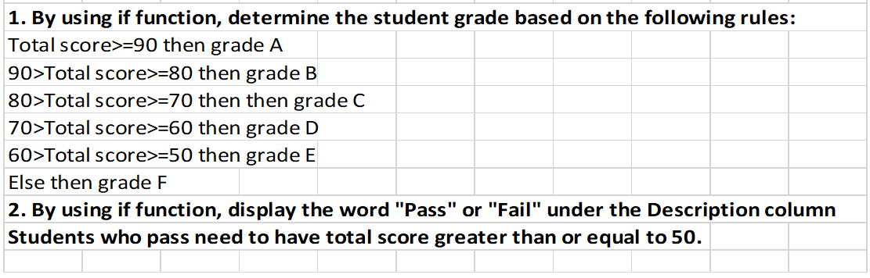

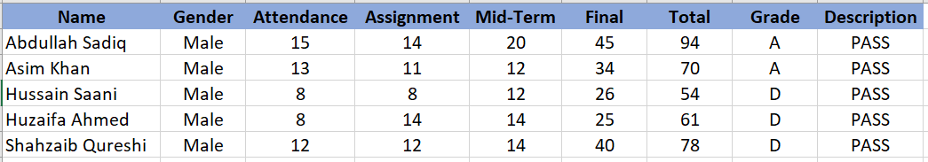

Task No 02: Perform the following task on the Excel sheet provided given below for performing the given task in this lab.

1. Insert a Pivot Table for the given data.

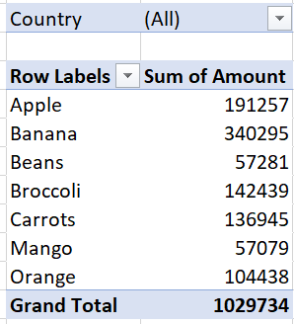

1. Find out which products do we export the most to USA?

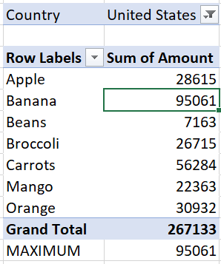

1. Find the summary calculation "Maximum" and save the results.

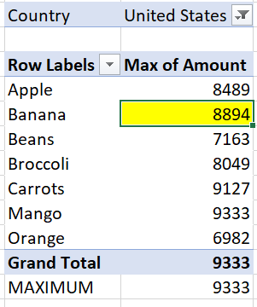

1. Construct a 2-dimensional Pivot Table.

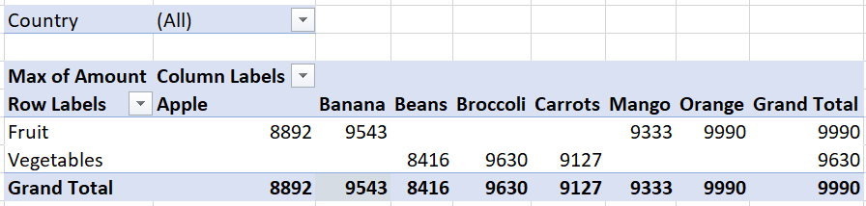

1. Insert the pivot Chart for 2-dimensional Pivot Table.

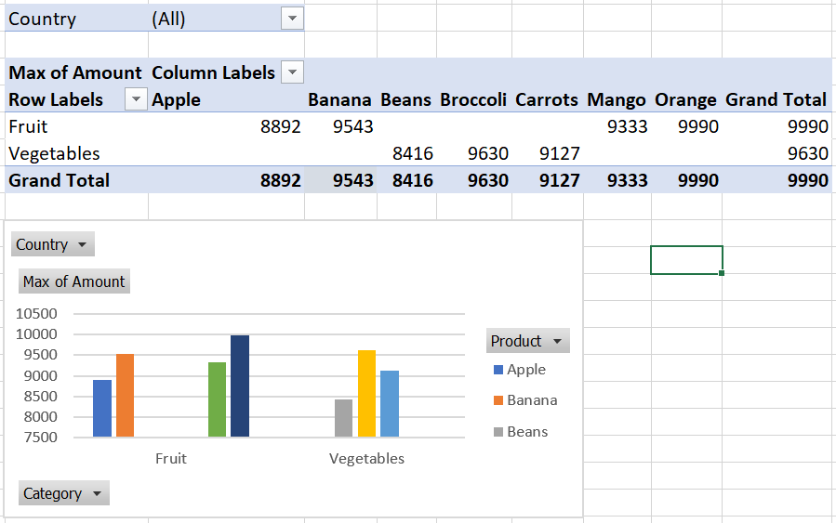

1. Use the country filter that only show the total amount of each product exported to the Canada in Pivot Chart.

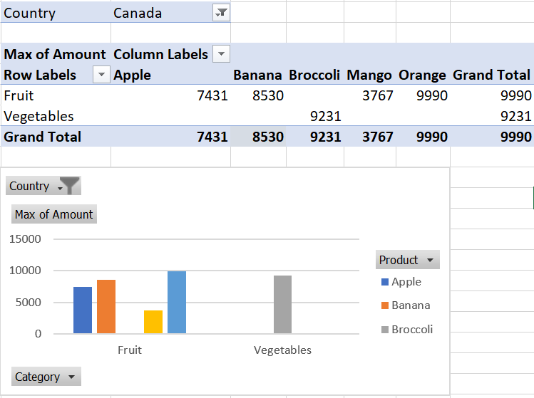

1. Use the Category filter to only show the vegetables exported to each country.

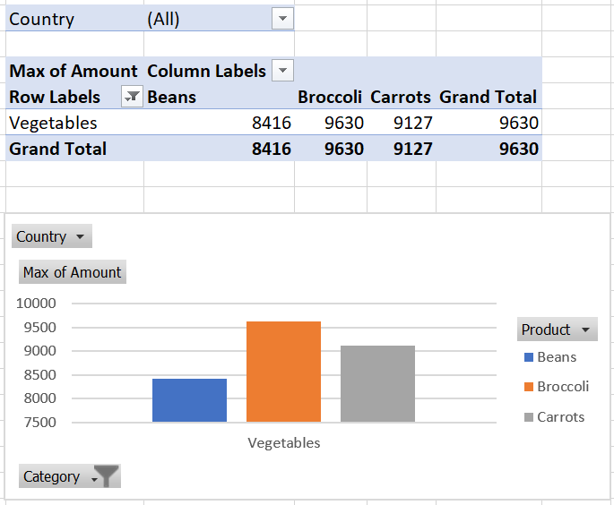

Task No 03: Perform the number system conversion on any number of your choice with the help of formulae provided by Excel.

